# Assignment 2 – Grocery shopping system Application

## Dependencies:

### Netbeans - Webapplication

### Maven Json – 20180813 <https://mvnrepository.com/artifact/org.json/json/20180813>

### Android studio

* Gson - com.google.code.gson:gson:2.2.4 (Added via build.gradle implementation)

## Application description:

My android application is based off my JSF Grocery shopping system. There is a total of four different RESTful services, each including different operations. Each service once logged into the application requires Authentication via a Basic Auth header.

**Services:**

* API
  + User
    - GET
    - Register
      * POST
  + Product
    - {ID}
      * GET
    - ALL
      * GET
      * {Search}
        + GET
        + Store

{ID}

GET

* + Order
    - Place
      * POST
  + Cart
    - Increment
      * {ID}
        + PUT
    - Decrement
      * {ID}
        + PUT
    - GET

## Login/Registration:

The app is launched to the login screen. Your username and password is required to login. Logging in uses the /User/Get service, it sends the Basic auth string and returns the users details if correct. If incorrect an authentication error is thrown.

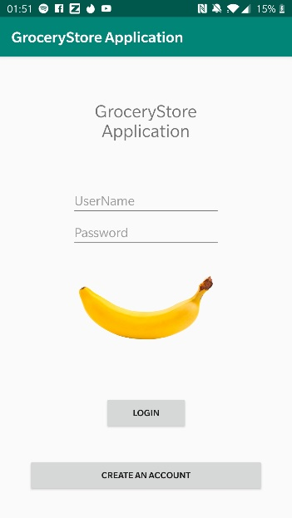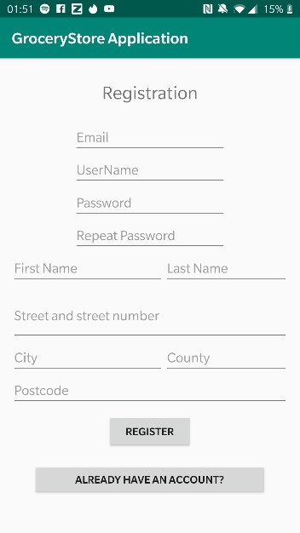

To register you need to fill in all of the details. The password needs to be longer than six characters, and they need to match.

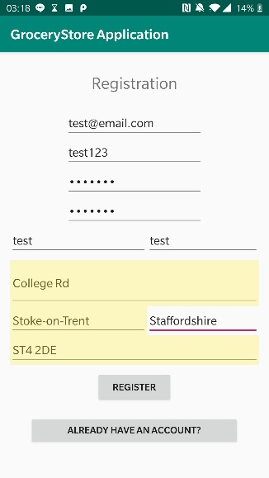

Username: test123



Password: test123

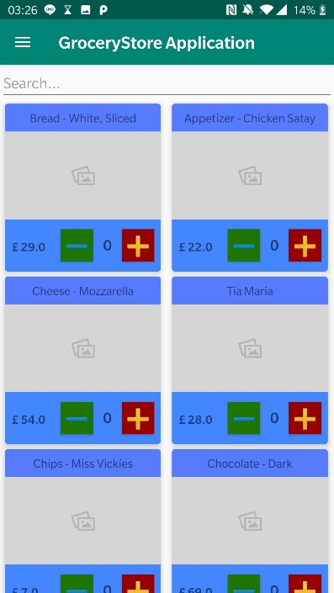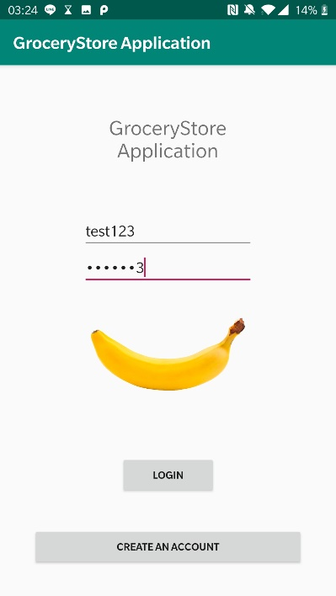Logging in with our newly created account will take us to the products page.

